Chapter 1
Overview
Enterprise JavaBeans (EJB) is a server-side component architecture that simplifies the process of building enterprise-class distributed component applications in Java. By using EJB, you can write scalable, reliable, and secure applications without writing your own complex distributed component framework. EJB is about rapid application development for the server side; you can quickly and easily construct server-side components in Java by leveraging a prewritten distributed infrastructure provided by the industry. EJB is designed to support application portability and reusability across any vendor’s enterprise middleware services.
If you are new to enterprise computing, these concepts will be made very clear shortly. EJB is a complicated subject and thus deserves a thorough explanation. In this chapter, we’ll introduce EJB by answering the following questions:
- What plumbing do you need to build a robust distributed object deployment?
- What is EJB, and what value does it add?
- Who are the players in the EJB Ecosystem?
Let’s kick things off with a brainstorming session.
The Motivation for EJB
Figure 1.X shows a typical business application. This application could exist in any vertical industry, and could solve any business problem. Here are some examples:
- A stock trading system
- A banking application
- A customer call center
- A procurement system
- An insurance risk analysis application.
Notice that this application is a distributed system. We broke up what would normally be a large, monolithic application, and divorced each layer of the application from the others, so that each layer is completely independent and distinct.
Take a look at this picture, and ask yourself the following question based purely on your personal experience and intuition: If we take a monolithic application and break it up into a distributed system, with multiple clients connecting to multiple servers and databases over a network, what do we need to worry about now?
Take a moment and think of as many issues that you can. Then turn the page and compare your list to ours. Don’t cheat!
@@@COMP: Make sure the Figure is on one page, and the table is not visible until the reader turns a physical page@@@
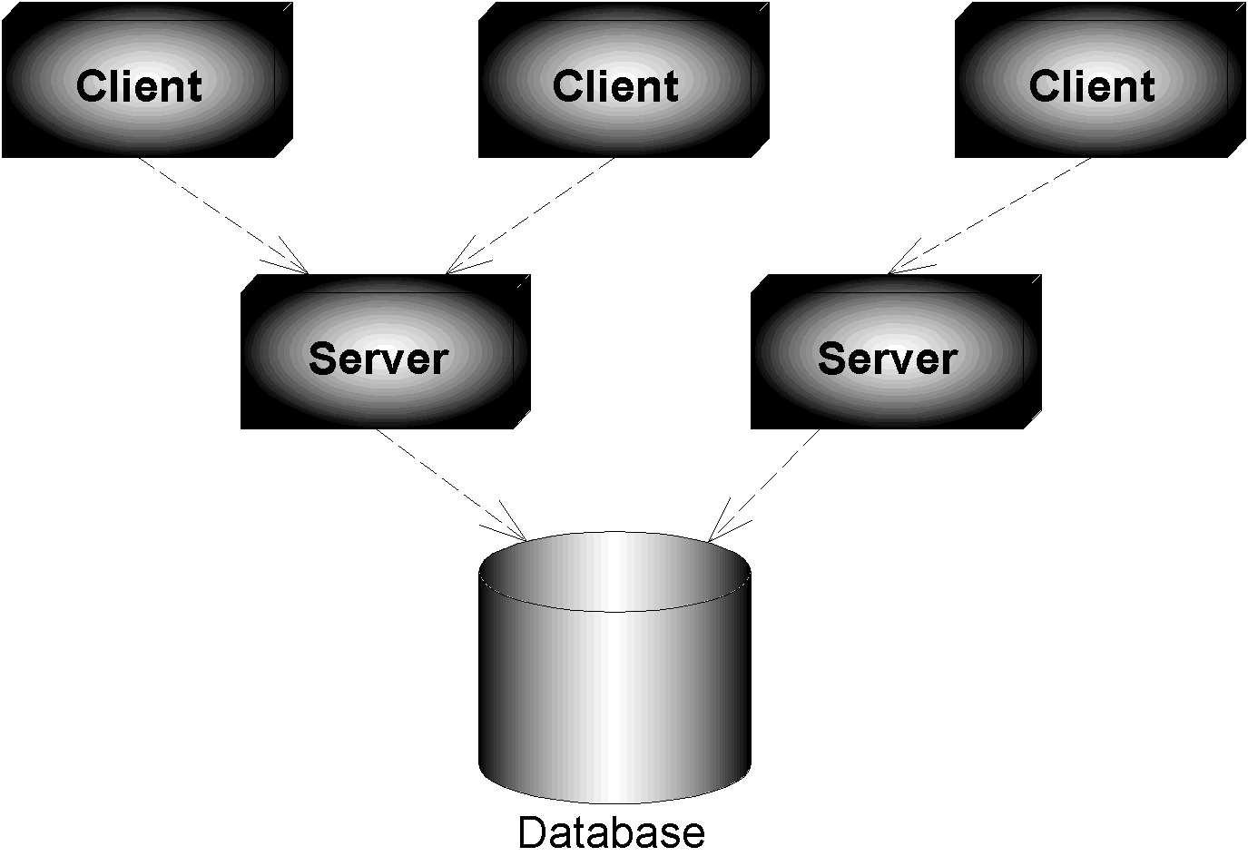Figure 1.X (3Tier.vsd) Your standard 3-tier deployment.
By now you should have a decent list of things you’d have to worry about when building large business systems. Here’s a short list of the ‘big things’ that we came up with. Don’t worry if you don’t understand all of them yet--you will.
- Remote method invocations. We need logic that connects a client and server together via a network connection. This includes dispatching method requests, brokering of parameters, and more.
- Load-balancing. Clients must be fairly routed to servers. If a server is overloaded, a different server should be chosen.
- Transparent fail-over. If a server crashes, or if the network crashes, can clients be re-routed to other servers without interruption of service? If so, how fast does fail-over happen? Seconds? Minutes? What is acceptable for your business problem?
- Back-end integration. Code needs to be written to persist business data into databases, as well as integrate with legacy systems that may already exist.
- Transactions. What if 2 clients access the same row of the database simultaneously? Or what if the database crashes? Transactions protect you from these issues.
- Clustering. What if the server contains state when it crashes? Is that state replicated across all servers, so that can clients use a different server?
- Dynamic redeployment. How do you perform software upgrades while the site is running? Do you need to take a machine down, or can you keep it running?
- Clean shutdown. If you need to shut a server down, can you do it in a smooth, clean manner so that you don’t interrupt service to clients who are currently using the server?
- Logging and auditing. If something goes wrong, is there a log that we can consult to determine the cause of the problem? A log would help us to debug the problem so it doesn’t happen again.
- Systems Management. In the event of a catastrophic failure, who is monitoring our system? We would like monitoring software that paged a system administrator in case of these catastrophes.
- Threading. Now that we have many clients connecting to a server, that server is going to need the capability of processing multiple client requests simultaneously. This means the server must be coded to be multi-threaded.
- Message-oriented middleware. Certain types of requests should be message-based where the clients and servers are very loosely coupled. We need infrastructure to accommodate messaging.
- Object lifecycle. The objects that live within the server need to be created or destroyed when client traffic increases or decreases, respectively.
- Resource pooling. If a client is not currently using a server, then that server’s precious resources can be returned to a pool, and will be reused when other clients connect. This includes sockets (such as database connections), as well as objects that live within the server.
- Security. The servers and databases need to be shielded from unwanted saboteurs. Known users must only be allowed to perform operations that they have rights to perform.
- Caching. Let’s assume there is some database data that all clients share and make use of, such as a common product catalog. Why should your servers retrieve that same catalog data from the database over and over again? You could keep that data around in the servers’ memory and avoid costly network roundtrips and database hits.
- And much, much, much more.
Each of these issues is a separate service that needs to be addressed for serious server-side computing. These services are needed in any business problem, and in any vertical industry. And each of these services requires a lot of thought and a lot of plumbing to resolve. Together, these services are called middleware.
In the past, most companies would build their own middleware. For example, a financial services firm might build some of the middleware services above to help them put together a stock trading system.
These days, companies that build their own middleware are setting themselves up for failure. High-end middleware is hideously complicated to build and maintain, requires expert-level knowledge, and is completely orthogonal to most companies’ core business. Why not build instead of buy?
The application server was born to let you buy these middleware services, rather than build them yourself. Application servers provide you with common middleware services, such as resource pooling, networking, and more. Application servers allow you to focus on your application, and not worry about the middleware you need for a robust server-side deployment. You write the code that’s specific to your vertical industry, and deploy that code into the runtime environment of an application server. You’ve just solved your business problem by dividing and conquering.
Divide and Conquer to the extreme
We’ve just discussed how you can gain your middleware from an application server, empowering you to focus on your business problem. But there’s even better news: you may be able to buy a partial solution to the business problem itself.
To achieve this, you need to build your application out of components. A component is code that implements a set of well-defined interfaces. It is a manageable, discrete chunk of logic. Components are not entire applications--they cannot run alone. Rather, they can be used as puzzle pieces to solve some larger problem.
The idea of software components is very powerful. A company can purchase a well-defined module that solves a problem and combine it with other components to solve larger problems. For example, consider a software component that computes the price of goods. We’ll call this a pricing component. You hand the pricing component information about a set of products, and it figures out the total price of the order.
The pricing problem can get quite hairy. For example, let’s assume we’re ordering computer parts, such as memory and hard drives. The pricing component figures out the correct price based on a set of pricing rules such as:
Base prices of a single memory upgrade or a single hard disk
Quantity discounts that a customer receives for ordering more than 10 memory modules
Bundling discounts that the customer receives for ordering both memory and a hard disk
Preferred customer discounts that you can give to big-name customers
Locale discounts depending on where the customer lives
Overhead costs such as shipping and taxes
These pricing rules are in no way unique to ordering computer parts. Other industries, such as health care, appliances, airline tickets, and others need the same pricing functionality. Obviously, it would be a huge waste of resources if each company that needed complex pricing had to write its own sophisticated pricing engine. Thus, it makes sense that a vendor provides a generic pricing component that can be reused over and over again for different customers. For example:
- The U.S. Postal Service can use the pricing component to compute shipping costs for mailing packages. This is shown in Figure 1.X.
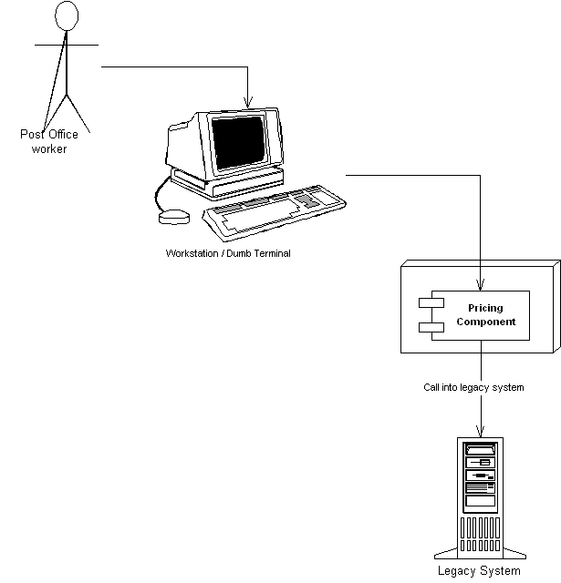Figure 1.X Reusing a pricing component for the U.S. Postal Service.
- An automobile manufacturer can use the pricing component to discriminate prices for cars. For example, the manufacturer can set up a Web site that allows customers to get price quotes for cars over the Internet. Figure 1.X illustrates this scenario.
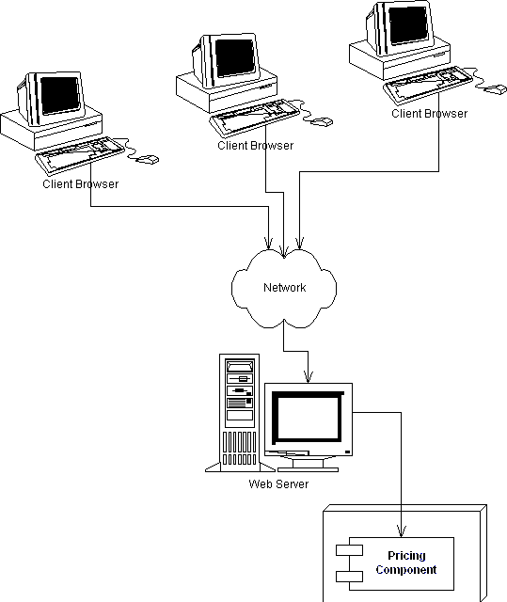
Figure 1.X Reusing a pricing component for quoting car prices over the Internet.
- An online grocery store can use the pricing component as a discrete part of a complete workflow solution. When a customer purchases groceries over the Web, the pricing component first computes the price of the groceries. Next, a different vendor’s component bills the customer with the generated price. Finally, a third component fulfills the order, setting things in motion for the groceries to be delivered to the end user. We depict this in Figure 1.X.
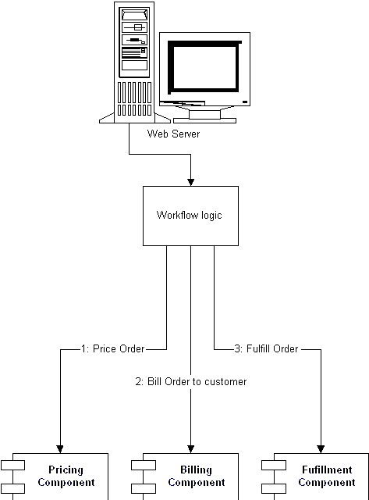
Figure 1.X Reusing a pricing component as part of an e-commerce workflow solution.
Reusable components are quite enticing because components promote rapid application development. An IT shop can quickly assemble an application from prewritten components, rather than writing the entire application from scratch. This means:
The IT shop needs less in-house expertise. The IT shop can consider the pricing component to be a black box, and it does not need experts in complex pricing algorithms.
The application is assembled faster. The component vendor has already written the tough logic, and the IT shop can leverage that work, saving development time.
There is a lower total cost of ownership. The component vendor’s cash cow is its components, and therefore it must provide top-notch documentation, support, and maintenance if it is to stay in business. Because the component vendor is an expert in its field, the component generally has fewer bugs and higher performance than an IT shop’s home-grown solution. This reduces the IT shop’s maintenance costs.
Thus, once the rules of engagement have been laid down for how components should be written, a component marketplace is born, where vendors can sell re-usable components to companies. The components are deployed within application servers, which give the needed middleware.
Is a component marketplace a myth?
There is a very small component marketplace today. For years we’ve been hoping that the marketplace will explode, but it is behind. There are several reasons for Independent Software Vendors (ISVs) not shipping components:

@@@COMP: UL within NT@@@
Maturity. Since components live inside application servers, the application servers must be mature before we see components written to those servers.
Politics. Many ISVs have written their own application servers. Some (falsely) view this as a competitive advantage.
Questionable value. Many ISVs are customer-driven (meaning they prioritize what their customers are asking for). Since components are new to many customers, many of them are not asking for their ISVs to support components.

It is our opinion that the marketplace will eventually explode, and it’s just a matter of time. If you represent an ISV, this could be a fantastic opportunity for you. And the good news is that it’s already beginning to happen. Most packaged E-Commerce ISVs (such as Ariba, Broadvision, Vignette, etc) are shipping or have announced support for server-side Java technologies.

In the meantime, you’ll have to build your own components from scratch within your organizations. Some of our customers at The Middleware Company are attempting this by having departments provide components to other departments. In effect, that department is acting as an internal ISV.
Component Architectures
It has been a number of years now since the idea of multi-tier server-side deployments surfaced. Since then, well over fifty (50) application servers have appeared on the market. But unfortunately, there was no definition of what a middle-tier component really is. Because of this, each application server has been providing component services in a non-uniform, proprietary way. This means that once you bet on an application server, your code is locked into that vendor’s solution. This greatly reduces portability and is an especially tough pill to swallow in the Java world, which promotes portability. It also hampers the commerce of components because a customer cannot combine a component written to one application server with another component written to a different application server.
What we need is an agreement, or set of interfaces, between application servers and components. This agreement will enable any component to run within any application server. This will allow components to be switched in and out of various application servers, without having to change code or potentially even recompile the components themselves. This agreement is called component architecture, and is shown in Figure 1.X.
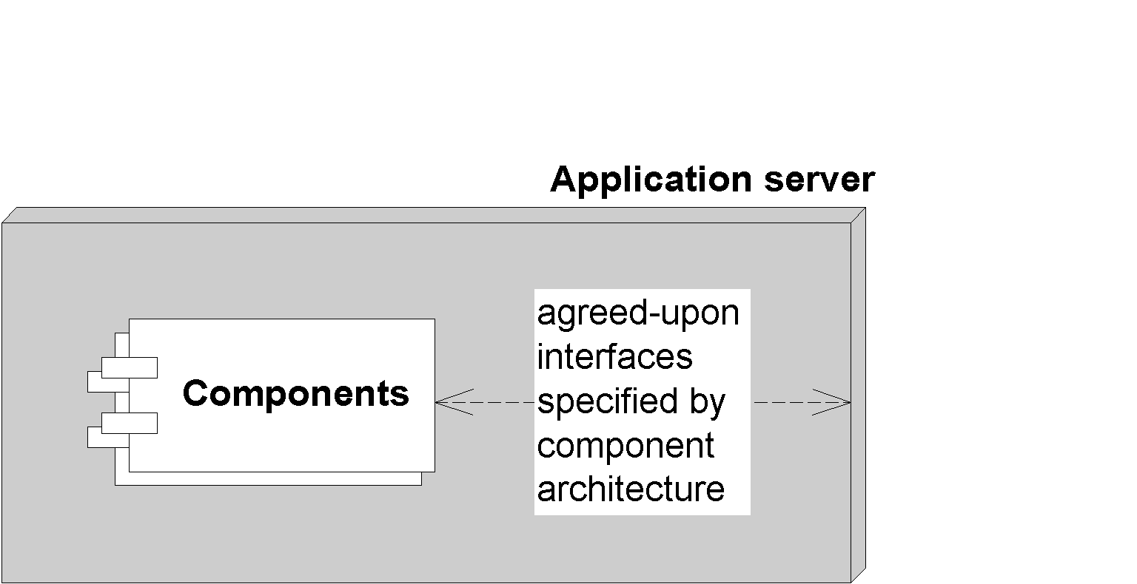Figure 1.X A component architecture.
Analogy
If you’re trying to explain components to a non-techie, try these analogies:
@@@COMP: BL within NT@@@
- Any CD player can play any compact disc because of the CD standard. Think of an application server as a CD player, and components as compact discs.
- In the United States, Any TV set can tune into any broadcast because of the NTSC standard. Think of an application server as a TV set, and components as television broadcasts.
Introducing Enterprise JavaBeans
The Enterprise JavaBeans (EJB) standard is a component architecture for deployable server-side components in Java. It is an agreement between components and application servers that enable any component to run in any application server. EJB components (also called enterprise beans) are deployable, and can be imported and loaded into an application server, which hosts those components.
The top three values of EJB are:
- It is agreed upon by the industry. Those who use EJB will benefit from its widespread use. Since everyone will be on the same page, in the future it will be easier to hire employees who understand your systems (since they may have prior EJB experience), learn best practices to improve your system (by reading books like this one), partner with businesses (since technology will be compatible), and sell software (since customers will accept your solution).
- Portability is easier. Since EJB is a standard, you do not need to gamble on a single vendor. Although portability will never be free, it is cheaper than without a standard.
- Rapid application development. Your application can be constructed faster since you get middleware from the application server. There’s also less of a mess to maintain.
How does EJB manifest itself?
Physically, EJB is actually three things in one:
@@@COMP: UL within NT@@@
A specification. This is a 700+ page Adobe Acrobat PDF file, downloadable from http://java.sun.com. This specification lays out the rules of engagement between components and application servers. It constricts how you program so that you can interoperate.
A set of Java interfaces. Components and application servers must conform to these interfaces. Since all components write to the same interfaces, they all look the same to the application server. Therefore, the application server can manage anyone’s components. You can download these interfaces from http://java.sun.com.
A test suite. Application servers must pass a rigorous set of tests to be certified as EJB-compliant. This reduces headaches for component developers, because they know for sure that their components will be portable.
Why Java?
EJB components must be written in Java only, and require an organizational dedication to Java. This is indeed a serious restriction. The good news, however, is that Java is an ideal language to build components, for many reasons:
Interface/implementation separation. We need a clean interface/implementation separation to ship components. After all, customers who purchase components shouldn’t be messing with implementation. Upgrades and support will become horrendous. Java supports this at a syntactic level via the interface keyword and class keyword.
Interpreted. Since Java is interpreted, it is safe. In Java, if a thread dies, the application stays up. Pointers are no longer an issue. Memory leaks occur much less often. This safety is extremely important for mission-critical applications. Sure, this might make your application slower, but 90% of all business problems are glorified Graphical User Interfaces (GUIs) to databases. That database is going to be your #1 bottleneck, not Java.
Cross-platform. Java runs on any platform. Since EJB is an application of Java, this means EJB should also easily run on any platform. This is valuable for customers who have invested in a variety of powerful hardware, such as Win32, UNIX, and mainframes. They do not want to throw these investments away.
Note
EJB is part of a larger platform, called the Java 2 Platform, Enterprise Edition (J2EE). There are two major competitors to this platform:
@@@COMP: BL within NT@@@
- Microsoft’s COM+, part of the Microsoft.NET platform
- The Object Management Group (OMG’s) Common Object Request Broker Architecture (CORBA)
If you’re curious about J2EE and its competitors, see Chapter X.
EJB as a business solution
EJB is specifically used to help solve business problems. EJB components (enterprise beans) might perform any of the following tasks:
Perform business logic. Examples include computing the taxes on the shopping cart, ensuring that the manager has the authority to approve the purchase order, or sending an order confirmation email using the JavaMail API.
Access a database. Examples include submitting an order for books, transferring money between two bank accounts, or calling a stored procedure to retrieve a trouble ticket in a customer support system. Enterprise beans achieve database access using the Java Database Connectivity (JDBC) API.
Access another system. Examples include calling a high-performing CICS legacy system written in COBOL that computes the risk factor for a new insurance account, calling a legacy VSAM data store, or calling SAP R/3. Enterprise beans achieve existing application integration via the Java Connector Architecture (JCA).
EJB components are not GUI components. Rather, enterprise beans sit behind the GUIs and do all the hard work. Examples of GUIs that can connect to enterprise beans include:
Thick clients. Thick clients execute on a user’s desktop. They could connect via the network with EJB components that live on a server. These EJB components may perform any of the tasks listed above (business logic, database logic, or accessing other systems). Thick clients in Java include applets and applications.
Dynamically generated web pages. Web sites that are complex need their web pages generated differently on each request. For example, the homepage for Amazon.com is completely different for each user depending on his profile. Java servlets and JavaServer Pages (JSPs) are used for this purpose. They live within a Web server and can connect to EJB components, generating pages differently based upon the values returned from the EJB layer.
XML-based web service wrappers. Some business problems have no user interface at all. Rather, they exist to serve other business partners that may provide their own user interface. For example, Dell Computer Corporation needs to purchase Intel chips to manufacture desktop computers. Intel could expose a web service that enables Dell’s software to connect and order chips. In this case, Intel’s system does not have a user interface of its own, but rather acts as a web service. Possible technologies used here include SOAP, UDDI, WSDL, and ebXML.
The real difference between GUI components (thick clients, dynamically generated web pages, and web service wrappers) and enterprise beans is the domain of which each component type is intended to be a part. GUI components are well suited to handle client-side operations, such as rendering GUIs (although they don’t necessarily need to have one), performing other presentation-related logic, and lightweight business logic operations. They deal directly with the end-user or business partner.
Enterprise beans, on the other hand, are not intended for the client side, but are server-side components. They are meant to perform server-side operations, such as executing complex algorithms or performing high-volume business transactions. The server side has different kinds of needs from a rich GUI environment. Server-side components need to run in a highly available (24x7), fault-tolerant, transactional, and multiuser secure environment. The application server provides this high-end server-side environment for the enterprise beans, and it provides the runtime containment necessary to manage enterprise beans.
Finally, note that applets, servlets, and enterprise beans are not “either-or” technologies. You can provide a user interface to your enterprise beans with applets or servlets (shown in Figure 1.X).
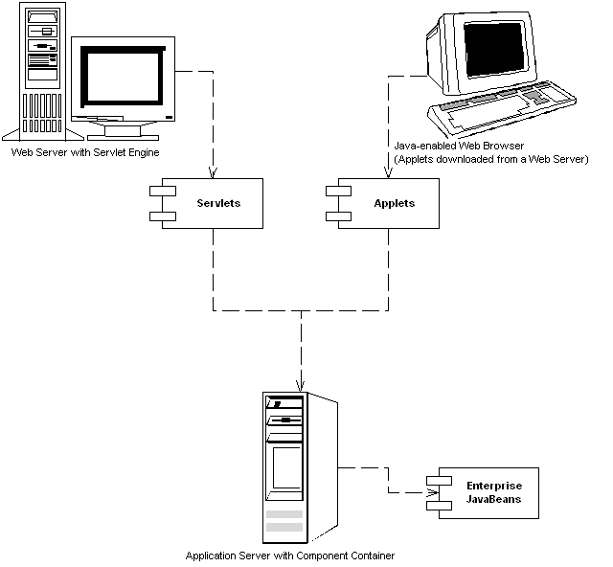Figure 1.X Applets, servlets, and Enterprise JavaBeans.

JavaBeans vs. Enterprise JavaBeans
You may have heard of another standard called JavaBeans. JavaBeans are completely different from Enterprise JavaBeans.

In a nutshell, JavaBeans are Java classes that have get/set methods on them. You can consider them to be components, but they are much smaller than Enterprise JavaBeans. You can use JavaBeans to assemble larger components or to build entire applications. JavaBeans, however, are development components and are not deployable components. You typically do not deploy a JavaBean; rather, JavaBeans help you construct larger software that is deployable. And because they cannot be deployed, JavaBeans do not need a runtime environment in which to live. Since JavaBeans are just Java classes, they do not need an application server to instantiate them, to destroy them, and to provide other services to them. The application itself is made up of JavaBeans.
The EJB Ecosystem
To get an EJB deployment up and running successfully, you need more than just an application server and components. In fact, EJB encourages collaboration of more than seven different parties. Each of these parties is an expert in its own field and is responsible for a key part of a successful EJB deployment. Because each party is a specialist, the total time required to build an enterprise-class deployment is significantly reduced. Together, these players form the EJB Ecosystem.
Let’s discuss who the players are in the EJB Ecosystem. As you read on, think about your company’s business model to determine which role you fill. If you’re not sure, ask yourself what your business’ core competency is. Also think about what roles you might be playing in upcoming projects.
Note
The EJB Ecosystem is not for everyone. At my company, we’ve heard ghastly stories of businesses choosing EJB because everyone else is using it, or because it is new and exciting. Those are the wrong reasons to use EJB. For a complete discussion of when to (and when not to) use EJB, see Chapter X.
The bean provider
The bean provider supplies business components, or enterprise beans. Enterprise beans are not complete applications, but rather are deployable components that can be assembled into complete solutions. The bean provider could be an ISV selling components, or an internal department providing components to other departments.
An example of a bean provider that ships reusable components today is BEA, which sells the WebLogic Commerce Server for building e-business applications. In the future, traditional enterprise software vendors (such as sales force automation vendors, enterprise resource planning vendors, financial services vendors, and e-commerce vendors) will offer their software as enterprise beans or will provide connectors to their current technology.
The Application Assembler
The application assembler is the overall application architect. He or she is responsible for understanding how various components fit together and writes the applications that use components. He or she may even author a few components along the way. His or her job is to build an application from those components--an application that can be deployed in a number of settings. The application assembler is the consumer of the beans supplied by the bean provider.
The application assembler could perform any or all of the following tasks:
- Supply a user interface (perhaps Swing, servlet/JSP, application/applet, or web service wrapper).
- Write new enterprise beans to solve some problems specific to your business problem.
- Write the code that calls on components supplied by bean providers.
- Write code that maps data between components supplied by bean providers. After all, components won’t magically work together to solve a business problem--especially if different vendors write the components.
An example of application assembler is a systems integrator, a consulting firm, or an in-house programmer.
The EJB Deployer
After the application assembler builds the application, the application must then be deployed (and go live) in a running operational environment. Some challenges faced here include:
- Securing the deployment with a firewall.
- Choosing the right hardware to provide the needed level of scalability.
- Providing redundant hardware for fault-tolerance.
- Integrating with an LDAP server for security lists, such as Lotus Notes or Microsoft Exchange Server.
- Performance-tuning the system.
Unfortunately, the application assembler (who is usually a developer or systems analyst) may not be familiar with these issues. This is where the EJB deployer comes into play. EJB deployers are aware of specific operational environments and perform the tasks above. They understand how to deploy beans within servers and how to customize the beans for a specific environment. The EJB deployer has the freedom to adapt the beans, as well as the containers and servers, to the environment in which the beans are to be deployed.
An EJB deployer can be a staff person, an outside consultant, or a vendor. An example deployer is Loudcloud, which offers hosting solutions for EJB deployments.
The System Administrator
Once the deployment goes live, the system administrator steps in to oversee the stability of the operational solution. The system administrator is responsible for the upkeep and monitoring of the deployed system and may make use of runtime monitoring and management tools that the EJB server provides.
For example, a sophisticated EJB server might page a system administrator if a serious error occurs that requires immediate attention. Some EJB servers achieve this by developing hooks into professional monitoring products, such as Tivoli and Computer Associates. Others are providing their own systems management by supporting the Java Management Extension (JMX).
Qualities of Service in EJB
Monitoring of EJB deployments is not specified in the EJB specification. It is an optional service that advanced EJB servers can provide. At first blush, you might think this hampers portability. However, in reality this service should be provided transparently behind-the-scenes, and should not affect your application code. It is a quality of service that lies beneath the application level and exists at the systems level. Changing application servers should not affect your EJB code.

Other transparent qualities of service not specified in the EJB specification include load-balancing, transparent fail-over, caching, clustering, and connection pooling algorithms.
The container and server provider
The container provider supplies an EJB container (the application server). This is the runtime environment in which beans live. The container supplies middleware to the beans, and manages them. Examples of EJB containers are BEA’s WebLogic, The Sun-Netscape-AOL alliance’s iPlanet, IBM’s WebSphere, Oracle’s Oracle 9i, Persistence’s PowerTier, Brokat’s Gemstone/J, HP’s Bluestone, IONA’s iPortal, Inprise’s Inprise Application Server, and the jBoss open source code application server.
The server provider is the same as the container provider. Sun has not yet differentiated these (and they may never do so). We will use the terms EJB container and EJB server interchangeably in this book.
The Persistence Manager provider
The persistence manager provider is responsible for providing a persistence manager that plugs into an application server. Your components harness the persistence manager to map your business data into storage, such as mapping objects into relational databases.
The persistence manager may be written to understand how to persist business data to any storage type. Examples include legacy systems, flat file systems, relational databases, object databases, or a proprietary system.
The persistence manager provider may be the same as the container/server vendor, such as the case with IBM’s WebSphere that includes built-in persistence capabilities. Examples of ISV persistence manager providers include WebGain’s TOPLink, Thought Inc’s Cocobase.
The Tool Vendors
To facilitate the component development process, there should be a standardized way to build, manage, and maintain components. In the EJB Ecosystem, there are several Integrated Development Environments (IDEs) that assist you in rapidly building and debugging components. Examples are Symantec’s Visual Cafe, IBM’s VisualAge for Java, or Inprise’s JBuilder.
There are also tools that you can use to model components in the Unified Modeling Language (UML), which is the diagram style used in this book. You can then auto-generate EJB code from that UML. Examples of products in this space are Togethersoft’s Together/J and Rational’s Rational Rose.
There are other tools as well, such as tools to organize components (Flashline, ComponentSource), testing tools (JUnit, RSW Software), and build tools (Ant).
Summary of roles
Figure 1.X summarizes the interaction of the different parties in EJB
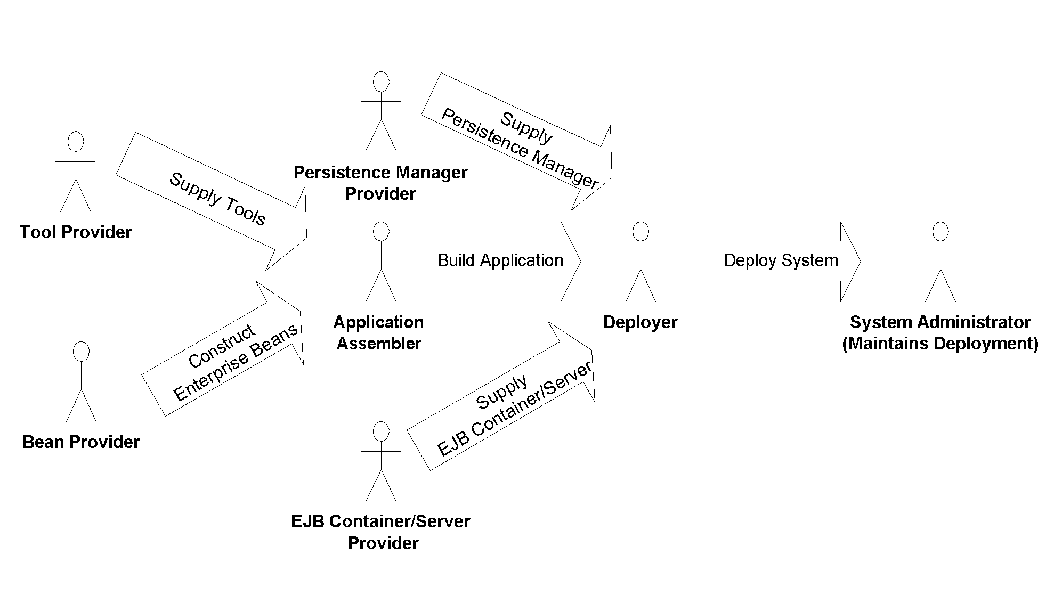Figure 1.X The parties of EJB.
You may be wondering why so many different participants are needed to provide an EJB deployment. The answer to this is that EJB enables companies or individuals to become experts in roles and that division of labor leads to best-of-breed deployments.
The EJB specification makes each role very clear and distinct, enabling experts in different areas to participate in a deployment without loss of interoperability. Note that there is also room for some of these roles to be combined as well. For example, the EJB server and EJB container today come from the same vendor. Or at a small startup company, the bean provider, application assembler, and deployer could all be the same person who’s trying to build a business solution using EJB from scratch.
For some of the parties, EJB merely suggests the possible duties that the party might assume, such as the system administrator overseeing the well-being of a deployed system. For other parties, such as the bean provider and container provider, EJB defines a set of strict interfaces and guidelines that must be followed or the entire model will break down. By clearly defining the roles of each party, EJB lays a foundation for a distributed, scalable component architecture where multiple vendors’ products can interoperate.
Summary
We’ve achieved a great deal in this chapter. First, we brainstormed a list of issues involved in a large, multi-tier deployment. We then understood that a server-side component architecture allows us to write complex business applications without understanding tricky middleware services. We then dived into the EJB standard, and fleshed out its value proposition. Finally, we investigated the different players involved in an EJB deployment. By working together, they can achieve a whole that is greater than the sum of its parts.
The good news is that we’re just getting started, and there are many more interesting and advanced topics ahead. The next chapter delves into the concept of request interception, which is the most difficult mental leap you need to make to fully understand EJB. Let’s go!

